Dear _________________________,

Thank you for registering for the Young Voices concert at the O2. You can practise all the songs at home by logging into My Classmate. You can do this on a laptop or any device that can access the internet. Please remember to check with somebody at home before you access anything online. Once you have got permission, enter the following URL into your internet browser: <https://myclassmate.ai/>

You should see this on your screen:

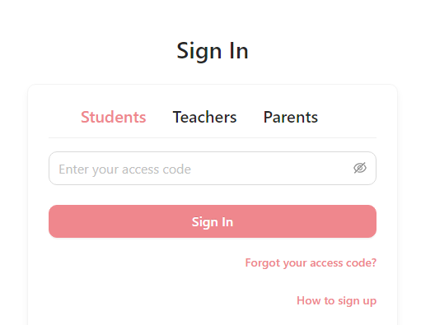

Select the ‘Students’ option and enter your unique access code which is attached to this letter. This will take you to your own ‘Dashboard’ and ‘Music Room’ where you can access all the vocal and backing tracks, lyric sheets and videos and dance videos. Remember, we need to try and memorise all of the words for the songs so it will be good to get practising regularly.

Enjoy!



Miss Wilce ☺