Plan, Learn, Review Grid (Week 3 18^{th-22nd} January)
Plan, Learn, Review is child-initiated time, and the children get to choose what they want to learn. Therefore, your child can choose to play with their toys or try one of the suggested activities. There is no pressure to complete any of these. If you have ideas of your own please feel free to do this instead. These ideas are linked to our remaining curriculum.
Communication and Language  - Talk a grown up through your ‘Happy Board. Explain what makes you happy. Why do those things make you feel happy?  - Discuss the feelings and emotions the Three Little Pigs might be experiencing at different stages of the story. E.g. How do they feel leaving home? How do they feel building their houses? How do they feel when the wolf comes? Etc. | Personal, Social and Emotional Development  - Create a ‘Happy Mood Board or Poster’. Cover it in pictures, photos, drawing and words of all the things which make you really happy.  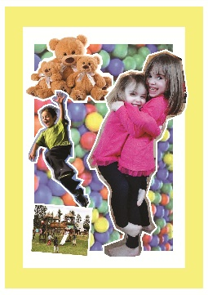 | Physical Development  - Complete our ‘Get Fit Bingo’ card and win a certificate!
Expressive Art and Design  - Can you paint a picture of the three little pigs or the big bad wolf?  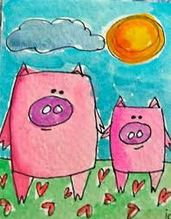  - Can you make a blow painting using a straw? You can pretend to be the Big Bad Wolf!  - Can you listen to a Three Little Pigs song on YouTube? Can you sing along? Can you make up your own song? (Debbie and Friends on YouTube do a three little pigs song). | Understanding The World  - Watch fact videos about pigs or wolves on YouTube – See what you can find out!  - Watch ‘Space Week’ on Cbeebies at 4:50pm every day. They will be working from the National Space Centre!  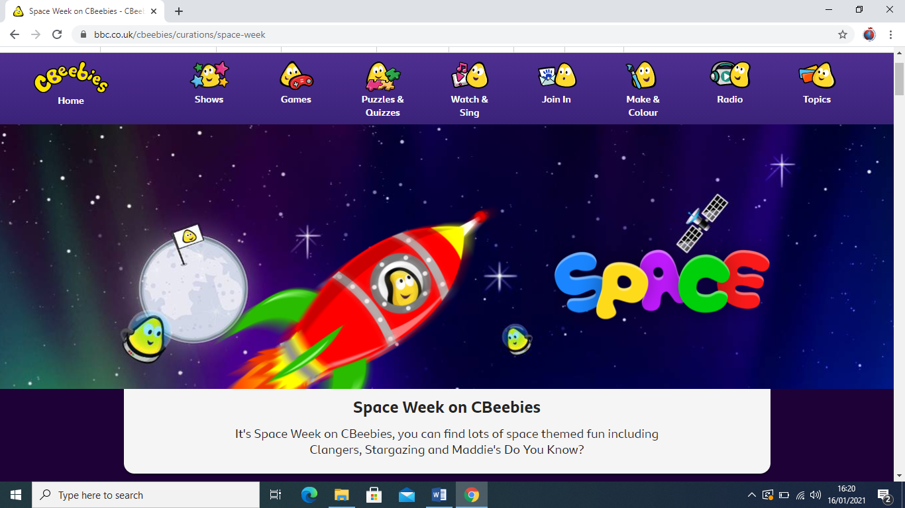  - Have a go at looking at the RSPB Bird watch on our website under Week 3 home learning. See which birds you can find!  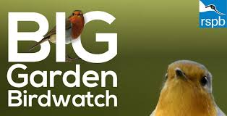 | Literacy  - Can you draw a story path for ‘The Three Little Pigs’.  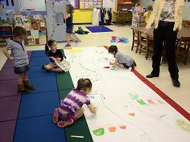  - Do your daily reading on Bug Club.  - Can you make a book of ‘The Three Little Pigs’, you can make your own version if you want to!  - Can you design a front cover for the book, ‘The Three Little Pigs’  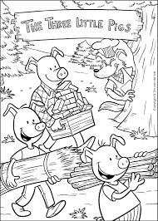
Maths

- Can you set up a shop with your toys? Can you give each item a price tag and use real coins to play? Maybe you can make a price where you need to add two coins together!

- Can you make 3 different houses of 3 different heights? Which one is the tallest, which one is the shortest?

