Literacy/Phonics
Comprehension
- Demonstrate understanding of what has been read to them by retelling stories and narratives using their own words and recently introduced vocabulary.
-Anticipate – where appropriate – key events in stories.
-Use and understand recently introduced vocabulary during discussions about stories, non-fiction, rhymes and poems and during role-play.
Word Reading
-To recognise Phase 3 digraphs and read them in words.
-Say a sound for each letter in the alphabet and at least 10 digraphs.
-Read words consistent with their phonic knowledge by sound blending.
-Reading aloud simple sentences and books that are consistent with their phonic knowledge, including some common exception words.
Writing
-Write recognisable letters, most of which are correctly formed.
-Spell words by identifying sounds in them and representing the sounds with a letter or letters.
-Write simple phrases and sentences that can be read by others.

Personal Social and Emotional
Self-regulation
-To be able to identify and moderate own feelings.
-To begin understanding their next steps into Year 1 and feeling ready to try a new challenge.
-To be able to work towards simple goals and wait for what they want.
-To be able to focus attention on what others are saying and show an ability to follow instructions involving several ideas or actions.

Managing self
-To see themselves as a unique and valued individual.
-Be confident to try new activities and show independence, resilience and perseverance in the face of challenge.
-Understand the rules and know right from wrong.
Manage their own basic hygiene and personal needs, including dressing, going to the toilet and understanding the importance of healthy food choices.
Building relationships
-Show sensitivity to others needs and feelings.
-Work and play cooperatively and take turns with others.
-Form positive attachments to adults and friendships with peers.

Communication and Language
Listening, attention and understanding/Speaking
-Listen and respond with relevant questions, comments, or actions.
Attend to others in play.
-Listen to texts, fiction/non-fiction to deepen their understanding of farming and farm animals.
-Make comments and clarify thinking with questions.
-Retell the story once they have developed a deep familiarity with the text; some as exact repetition and some in their own words.
-Speak in well-formed sentences with some detail.
-Use new vocabulary in different contexts.
-Use past, present, and future tenses in conversation with peers and adults. Use conjunctions to extend and articulate their ideas.
-Participate in small group, class and one-to-one discussions, offering their own ideas, using recently introduced vocabulary.
-Offer explanations for why things might happen, making use of recently introduced vocabulary from stories, non-fiction, rhymes and poems when appropriate.

What lives on a farm and why are they important?
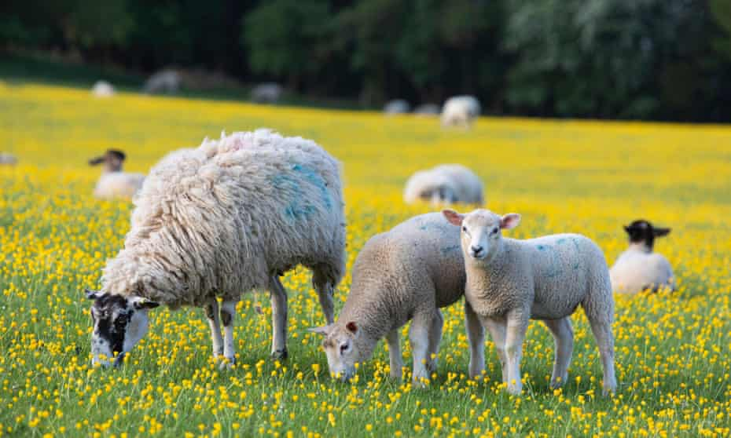
Through this topic, the children will learn about farms, the animals that live there and the jobs that happen every day, which contribute to our community. The children will learn about where food comes from and food that is specifically and seasonally grown in England. The children will learn about the importance of the animals on the farm and the scientific names of their young. They will learn about how these animals are cared for and understand their needs.

Maths
Number/Numerical Patterns
-To recite and use part whole models to make number bonds from 0-5 and some to 10.
-To understanding doubling facts.
-To have a deep understanding of number to 10, including the composition of each number.
-To learn numbers past 10 and verbally count beyond 20, recognising the pattern of the counting system.
-Compare quantities up to 10 in different contexts, recognising when one quantity is greater than, less than or the same as the other quantity.
-To solve addition and subtraction problems.
-To understand odd and even numbers.
-To solve a range of mathematical problems independently.

Physical Development
Gross motor skills
- Daily Yoga, Dances.
- Confidently and safely use a range of large and small apparatus indoors and outside, alone and in a group.
- To learn how to take part in a range of races.
-Negotiate space and obstacles safely, with consideration for themselves and others.
-Demonstrate strength, balance and coordination when playing.
-Move energetically, such as running, jumping, dancing, hopping, skipping and climbing
Fine motor skills
-Hold a pencil effectively in preparation for fluent writing – using the tripod grip in almost all cases.
-Use a range of small tools, including scissors, paintbrushes and cutlery.
-Begin to show accuracy and care when drawing.

Expressive Art and Design
Creating with materials
-To continue woodwork skills: hammering/joining.
-Safely use and explore a variety of materials, tools and techniques, experimenting with colour, design, texture, form and function.
-Share their creations, explaining the processes they have used.
-Make use of props and materials when role-playing characters in narrative and stories.
Being imaginative and expressive
-Listen attentively, move to, and talk about music, expressing their feelings and responses.
-To learn songs about farms and farm animals.
-Invent, adapt and recount narrative and stories with peers and their teachers.
-Perform songs, rhymes, poems and stories with others, and – when appropriate – try to move in time with music

Understanding the World
Past and present
- Talk about the lives of the people around them and their roles in society.
-To know some similarities and differences between things in the past and now, drawing on their own experiences and what has been read in class.
-To understand the past through settings, characters and events encountered in books read in class and storytelling.
People, cultures and communities
- Describe their immediate environment using knowledge from observations, discussions, stories, non-fiction texts and maps.
-Explain some similarities and differences between life in this country and life in other countries, drawing on knowledge from stories, non-fiction texts and – when appropriate – maps.
The natural world
-To learn about life cycles of different animals.
-To learn about different environments and compare them.
-making observations and drawing pictures of animals and plants.
-To explore the seasonal changes from Spring into Summer.

^{Hooks}
^{Godstone Farm}
^{Sports Day}

Key Vocabulary

Farm
Animals – different names
Life Cycle
Seasonal Change
Machines
Wellbeing
Barn
Field
Hay
Seeds

Transition

