Literacy/Phonics
Comprehension
-Correctly sequence a story or event using pictures and/or captions.
-Make simple, plausible suggestions about what will happen next in a book they are reading.
-Know the difference between different types of texts (fiction, nonfiction, poetry)
-Make inferences to answer a question beginning 'Why do you think…?' in a picture book that has been read to them, where answer is clearly signposted.
-Play influenced by experience of books - gestures and actions used to act out a story, event or rhyme from text or illustrations.
Word Reading
-Can recognise Phase 2 and Phase 3 sounds and uses their skills to confidently read simple sentences or phrases.
-Reads all Phase 2 and most of Phase 3 tricky words.
Writing
-Continue to build on knowledge of letter sounds to build words in writing. Use writing in play. Use familiar words in their writing.
-To begin writing simple sentences independently.
-To learn to use a full stop at the end of a sentence.
-Spell words by drawing on knowledge of known grapheme correspondences. Make phonetically plausible attempts when writing more complex unknown words.
-Form most lower-case letters correctly, starting and finishing in the right place, going the right way round and correctly orientated. Include spaces between words. Beginning to form all capital letters and building confidence.
-To be able to draw and innovate story maps from well-known stories.

Personal Social and Emotional
Self-regulation
-To talk about their own abilities positively.
-To be confident to try new activities.
-Begin to show persistence when faced with challenges.
-To be able to set and work towards simple goals.
Managing self
-To show perseverance and resilience towards new activities.
-To manage themselves independently.
Building relationships
-Beginning to know that children think and respond in different ways to them.
-Show sensitivity to their own and others’ needs.
- To be able to think about the perspectives of others.
-Can keep play going by co-operating, listening, speaking, and explaining.
-Can reflect on the work of others and self-evaluate their own work.

Communication and Language
Listening and attention and understanding/Speaking
-Listen and understand instructions while busy with another task.
-Maintain activity while listening.
-Understand how, why, where questions.
-Describe events in some detail.
-Express ideas about feelings and experiences.
-Articulate their ideas and thoughts in well-formed sentences.
-Use language to reason.
-To be able to understand how to explain why things might happen, making use of recently introduced vocabulary from stories, non-fiction, rhymes and poems when appropriate.
-Make up stories linked to space.
-To be able to offer explanations for why things might happen, making use of recently introduced vocabulary from stories, nonfiction, rhymes and poems when appropriate.
- To know and be able to use the new vocabulary taught in Topic in discussions and play.

Why does it change from light to dark everyday?
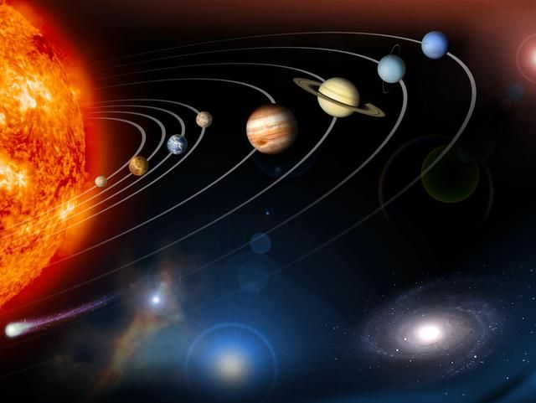
Through this topic, the children will learn all about space and our solar system. They will learn the names of the planets and how their environments differ. They will learn about space travel and the job of an astronaut. They will discover many exciting facts about astronomy. They will develop an understanding of time and the importance of light. They will also learn about different environments on Earth and consider how they may be similar or different to the environment they live in.
Maths
Number/Numerical Patterns
-To learn numbers, 9 and 10. To learn odd/even patterns in number.
-To explore the composition of numbers beyond 10.
-to subitise to 10 (number sense)
-To learn number bonds to 10.
-Counting patterns to 10 and beyond.
-To learn 3D shape names and features.
-To learn how to double/share amounts.
-Create repeating patterns.

Physical Development
Gross motor skills
- Daily Yoga, Dances.
-To follow PE scheme – Teach, Learn, Grown (Linked to QOD)
-To know and refine a range of ball skills including throwing, catching, kicking, passing, batting, and aiming.
- To know and consolidate travelling and balancing skills through building sequences.
-To be able to Experiment with direction and be able to change direction and speed whilst maintaining personal space.
Fine motor skills
-To practise correct handwriting which is accurate and efficient.
-To take part in daily finger gym activities before Phonics.
-Develop accuracy with colouring and drawing.
-To continue wood work skills.
-To use more challenging construction toys such as Knex and Meccano.

-To know what constitutes a healthy lifestyle.
-To be able to Use large and small apparatus safely and with some skill.
-To be able to Use large and small apparatus safely and with some skill.

Understanding the World
Past and present
- To learn some similarities and differences between things in the past and now, drawing on their own experiences.
People, cultures and communities
-To describe their immediate environment using knowledge from observations, discussions, stories, non-fiction texts and maps.
The natural world
-To learn about life cycles of frogs/butterflies.
-To learn about the solar system and the stars.
- Recount an event, orally, pictorial and/or with captions.
-To go on a simple walk and create maps for the area.
-Explore the natural world around them, making observations and drawing pictures of animals and plants.
-To be able to describe events in some detail and talk about what they observe in the natural world and growing observations.

^{Hooks}
^{Space Dome}
^{Tadpoles}

Expressive Art and Design
Creating with materials
- To be able to safely use and explore a variety of materials, tools and techniques.
To be able to experiment with colour, design, texture, form and function
- To be able to use what they have learnt about media and materials in original ways, thinking about uses and purposes.
- To be able to construct with a purpose.
-To design and plan models before creating them.
Being imaginative and expressive
-Listen attentively, move to, and talk about music, expressing their feelings and responses.
-To learn songs about the solar system.

Key Vocabulary

Story structure – beginning/ending
Fairy tale
Character/setting/problem/solution
Event
Adjective
Sentence
Spring
Easter
Christianity
Daffodil
Growth
Plant
Length
Height
Evil
Imagination
Conflict
Resolution
Morals

