Literacy/Phonics
Comprehension
-To retell stories/poems in correct sequence, draw on language patterns of stories (The Three Little Pigs).
-To use tales toolkit to demonstrate they can use correct language to retell a story with a beginning, middle and end.
-Give a simple opinion on a book they have read, when prompted.
-Play influenced by experience of books and innovate a well-known story with support.
Word Reading
- To knows the sounds for each letter in the alphabet and at least 10 diagraphs.
-To know and be able to read a range of tricky words matched to FFT Phonics Scheme.
-To be able to read words and simple sentences consistent with their phonic knowledge. To be able to explain what they have read.
Writing
-Writes most lower case letters correctly.
-Independently writes CVC and some CVCC words to make captions or labels,
-To be able to write simple sentences, using finger spaces between each word, with less support from adults.
-To learn how to write capital letters.

-To label story maps/tales toolkits with words or simple sentences.

Personal Social and Emotional
Self-regulation
-Can make choices and communicate what they need.
-Begin to show persistence when faced with challenges (growth mindset).
-Can reflect on work of others and self-evaluate their own work. Being able to set goals and achieve them.
Managing self
-To understand emotions (their own and others) and how to express them. To know strategies on how to regulate their feelings independently. Using feelings stones to support them when needed.
-More confident to tackle new challenges and with encouragement will keep going.
Building relationships
-To play by cooperating, listening, speakings and explaining and will listen to advice about how to solve disagreements.
-To work together acting out stories, taking turns to share roles.
-To learn to resolve conflicts without adult support.

Communication and Language
Listening and attention and understanding/Speaking
-To use adjectives to describe characters and settings.
-Maintain attention in different contexts and listen to a range of stories – ones made by the children in the class and ones read by adults.
-To be able to explain why things might happen, making use of recently introduced vocabulary from stories, nonfiction, rhymes and poems.
-Ask appropriate questions to find out more and check understanding. (planning/reviewing)
-Uses complex sentences to explain thoughts and ideas – explaining why.
-Begin to connect one idea or action to another using a range of connectives.
-Describe events in some detail.
-Uses talk in different ways, in imaginative play, to develop thinking, to collaborate and plan with others and to express ideas.
-Use correct language to retell a story, using Tales Toolkit to support them.

What is a fairy tale and how do we become storyteller?
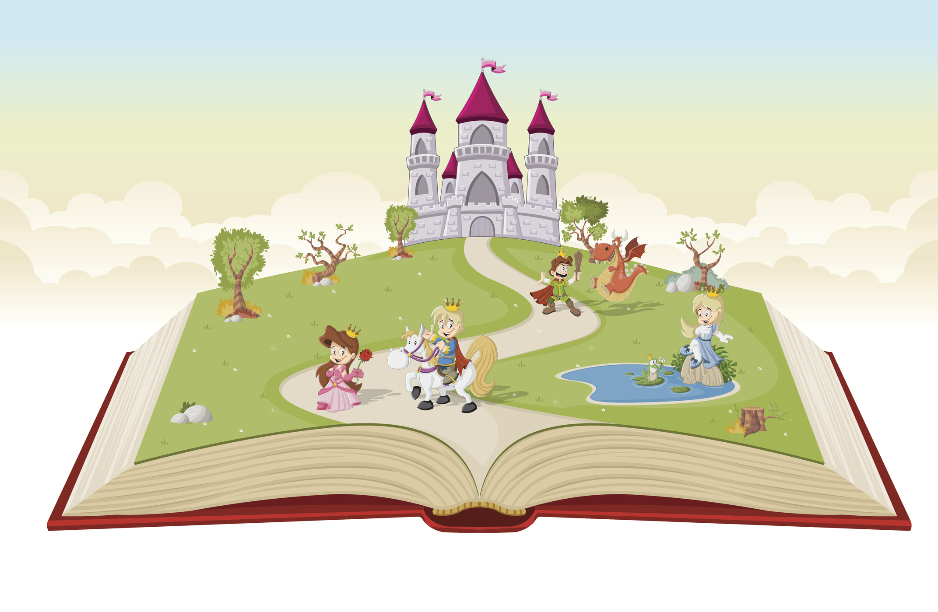
Through this topic, the children will listen to and learn about a range of magical and exciting fairy tales. They will learn about the key features that make a fairy tale and how to become confident and enthusiastic storytellers. The children will act out stories, retell them with actions, draw story maps and make up their own stories. Most importantly, the children will develop a love for the magic of reading and telling stories!
Maths
Number/Numerical Patterns
-To develop confidence in recalling number bonds from 0-8.
-To be able to say one more than/one less than numbers 0-8.
-To learn how to use a number line to count on/back.
-To continue to develop independent subtraction skills.
-To learn about 3D shapes and their features.
-To measure height, weight and time, using correct language linked to them.
-To subitise beyond 5 (number sense)
-To learn numbers 9 and 10.

Physical Development
Gross motor skills
-To follow PE scheme – Teach, Learn, Grow. (Linked to QOD)
- Daily Yoga, Dances.
- To be able to use equipment properly and move and land safely.
-To be able to work in a team collaborating and problem solving. (Outdoor and adventurous activities)
-Use skills learnt in BEAM to confidently catch, throw and kick balls.
Fine motor skills
-To practice handwriting and forming all letters from the alphabet correctly.
-To hold pencil more effectively, using pencil grip if needed. (Frog fingers)
-To take part in Finger Gym activities, Dough Disco, Finger Aerobics.
-To learn how to use woodwork resources.

Understanding the World
Past and present
-To look at fairy tales from the past – discuss the pictures and the story – comparing it to stories now.
People, cultures and communities
-To be able to recognise some similarities and differences between life in this country and life in other countries.
-To learn about the story of Easter and Easter celebrations and recap on previous learning of Christianity. To talk about some features of a Christian Church.
-To learn about Pancake Day and make their own pancakes.
The natural world
-To plant potato seeds and learn about what they need to grow.
-To learn about the season changes into Spring.
-To take part in Forest School sessions (learning opportunities change with each session.

Expressive Art and Design
Creating with materials
-To learn how to use tools to begin woodwork skills.
- To use different techniques and materials to achieve the desired effect and can talk about what has been created.
- Mixes colours to produce different shades and combines materials to create different textures.
-Use paints to create still life paintings (spring flowers) – looking at Van Gogh - sunflowers
Being imaginative and expressive
- Uses instruments to compose own music.
-Along with others, collects resources to develop own role play storylines.
-To learn an Easter song to perform to parents/carers.
^{Hooks}
World Book Day – Dressing up (2nd March)
^{Easter Celebrations}

Key Vocabulary

Story structure – beginning/middle/ending
Fairy tale
Character/setting/problem/solution
Adjective
Sentence
Spring
Easter
Christianity
Daffodil
Growth
Plant
Length/Weight/Height
3D/2D
Evil
Imagination
Conflict
Resolution
Morals
Number line
Wood Work – Saw, Hammer, Nails
Vocab from FFT Phonics Books

