**Music – How does music bring us together?**

Looking at musical genres and inspiring people

**Art and Design –What’s in a portrait?**

Exploring tints, tones and shades

Artist study – Amedeo Modigliani

Developing artistic skills using watercolours and acrylics

**DT – How are pneumatics used in the circus?**

To understand the design and function of pneumatic devices

To create a prototype

Assemble, join and combine materials

Select and use a range of materials

**English – Do all people have the same dreams?**

Key Texts: Little People, Big Dreams

Writing genres: Biographical writing

SPaG and reading comprehension skills taught through key texts.

**PSHE – How can we look after our wellbeing?**

Zones of regulations.

What is diversity?

Dyslexia

**Do All People have the same dreams?**

**RE – Why do some people pray and believe in God?**

Understand and give examples of why people pray (and it’s importance in the lives of others.)

Generate ideas and reasons, as what the nature of God is.

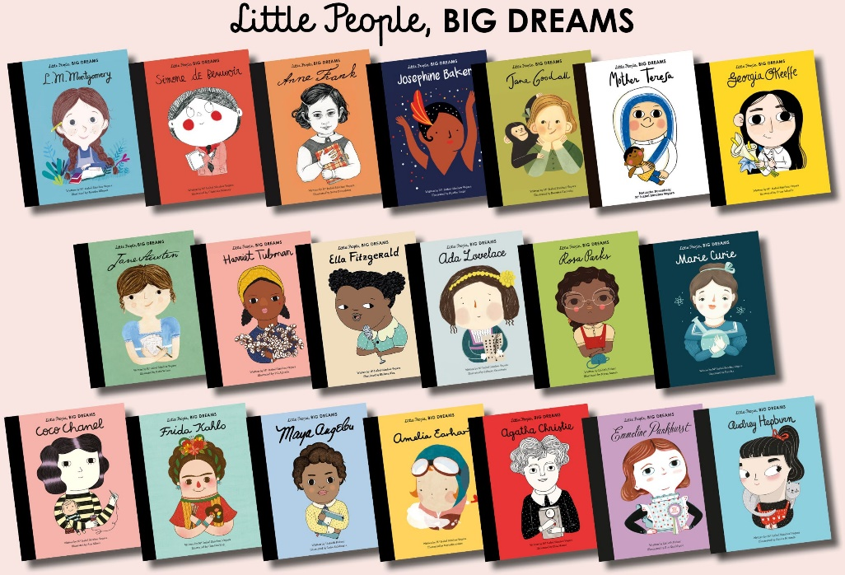

**PE**

Outdoor: **How can we use a range of skills and tactics to improve our performance?**

* Hockey

Understand the basic rules

Develop passing, defending and attacking skills

Use key skills in a game situation

* Multi-skills

Develop fundamental skills and movement

Develop tactics, rules and teamwork

**Computing**

Use Lego Wedo to solve algorithm problems and use basic code.

**French - How can we build on our existing French knowledge?**

Listening and responding, speaking, reading, writing and inter-cultural skills.

**Science – What is sound and how do we hear?**

Understanding and explaining what sound is, how it is formed, how it travels and how we can manipulate different sounds.