Literacy/Phonics
Comprehension
-To learn to retell a short poem.
-To listen to a range of stories based on feelings and people. Focus texts – Colour Monster/Elmer.
-Hold book correctly and handle with care.
-To understand that a story has a beginning and end.
-To know the difference between text and illustrations. To explain what is happening in a picture.
Word Reading
-To begin learning letter-sound correspondence and begin orally blending. (Phase 2)
-Recognise some familiar words in print e.g. own name or logos.
Writing
-To begin Phase 2 sounds and form them using a range of mark making tools.
-To draw patterns and draw recognisable shapes.
-To give meaning to marks they make.
-To begin writing their own name by copying or from memory.
Personal Social and Emotional
Self-regulation
-To be able to express their own feelings and begin to understand others feelings.
-To follow simple transitions and routines across the day.
-To discuss likes/dislikes.
Managing self
-To try a range of new activities with confidence.
-To learn and understand the rules.
-Independently organise belongings in the morning.
Building relationships
-To learn how to share resources with others and take turns.
-To build new relationships with peers and adults.

Communication and Language
Listening, attention and understanding
-To learn how to listen in whole class/small group and why listening is important.
-To maintain attention in whole class/group activities for a short time.
-Follow one step instructions and understand why questions.
Speaking
-To speak and listen in small group, class and one to one discussions, using new vocabulary they have learnt linked to people and emotions.
-To express their emotions and opinions.
-To have conversations with their peers while playing.
-To use talk to organise play.

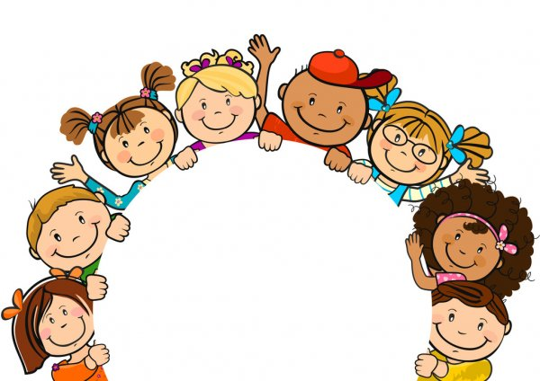
Why is it good to be me?
The children will learn about their new school, new routines and their learning environment. They will make new friendships with others. The children will learn about diversity and learn to respect cultural differences. They will deepen their understanding of emotions and learn how to express their thoughts and feelings.

Physical Development
Gross motor skills
-To move their bodies to express Write Dance stories.
-To learn how to use the Bikes with stabilisers. (Bike License)
-To develop the skills they need to manage the school day successfully: lining up and queuing, mealtimes, personal hygiene.
Fine motor skills
-To learn how to use crayons, chunky pens, chunky pencils to mark make (Write Dance)
-To take part in Finger Gym activities, Dough Disco, Finger Aerobics.

Maths
Number
-To learn numbers 0-5.
-Matching, sorting and comparing amounts.
Numerical Patterns
-Practising counting to 10, singing nursery rhymes or playing circle games.
-Sorting objects by colour, size and groups.
-Learning about the day routine (time).
-Exploring patterns through objects, colours or shapes.

Understanding the World
Past and present
-To learn about the adults at school and what their jobs are.
-To talk about similarities/differences between them and their peers.
-Talk about members of their immediate family and the relationships to them. Name and describe people who are familiar to them.
People, cultures and communities
-To learn about the school environment.
-To talk about themselves and things in their life that are special to them.
The natural world
-To talk about the features of their immediate environment with visual representations e.g., classroom maps, pictures of around school, seating maps and read commons signs and logos.
-To learn about seasonal change from summer to autumn. To make observations and drawings. To listen to non-fiction texts related to this.

^{Hooks}
Creative workshop – Colour Monster
School tours and meeting new people
All about me shoebox- Show and Tell

Expressive Art and Design
Creating with materials
-To draw portraits of themselves using broad tip pens.
-To learn how to use paints and paint tools
-To explore how to join materials together or manipulate with tools such as scissors. Finding the scissors, they feel comfortable using.
Being imaginative and expressive
-To sing nursery rhymes as a group.
-To act out simple stories through role-play or small world.
Key Vocabulary
Feelings – sad, happy, angry, calm, excited, surprised, scared, worried.
Emotions
Sharing
Turn taking
Patience
Kindness
Differences
People
Respect
Friendship
Phonics/Mat
Learning
Unique
Rules
Portrait

