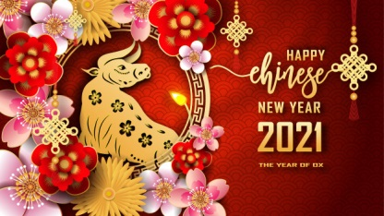

**Chinese New Year**

On 12th Februrary 2021 it is Chinese New Year! We want the children to learn about the Chinese culture and their celebrations so we are going to focus on this for the whole last week of term 3. We are very lucky to have a real Chinese Lion Dance workshop joining us on **10th Februrary**. Please do not forget to pay £7 through School Comms. If your family celebrates Chinese New Year and you would like to contribute anything to deepen the children’s knowledge and experiences please let your class teacher know via email.

**EYFS Newsletter**

**Term 3**

Happy New Year everyone! We hope you have a fantastic Christmas break filled with lots of joy and fun.

This term we have taken into account the children’s interests and decided to focus on **‘Our Superheroes’.**

Through this topic we will learn about people who are special to us and people in jobs which help us, for example police, medical staff, firefighters, teachers and many more. We will also learn about fictional superheroes and use our imaginations to make up our own special people.

our

**Phonics**

In Phonics this term the children will be focussing on learning **Phase 3 letter sounds** and use these sounds to read and write words. The children will be making words with the magnetic letters and practising writing using the correct letter formation. We will encourage the children to write more independently and begin teaching simple sentences.

Maths

In Maths the children will be focusing on recognising numbers past 10 and matching them to their value and putting them in the correct order. The children will also be learning about 3D shapes, recognising them in the environment and learning their names and features. We will be learning lots about 3D shapes through building.

In our provision we will also be encouraging the children to explore and use language related to capacity and weight.



**Thank you**

Thank you to all the parents who donated money to our fundraiser, we have been able to purchase lots of new toys and resources for your children to use and extend their learning.

**Key dates to remember…**

* 19th January ‘What I want to be when I grow up’ dress up day.
* Wednesdays: PE DAY: please wear PE kit.
* 10th Februrary: Chinese Dance Workshop

**Reminders…**

* Pleasure check that your child is wearing the **correct school uniform**, the school uniform policy is on our website. The children need to be wearing shirts not polo shirts.
* If you are providing a snack for your child please remember only **FRUIT OR VEGETABLES** are allowed.
* Please NAME all your children’s items of clothing, including ties otherwise they will go missing.
* Please rememeber to log into your **BUG CLUB** account to see what books your teacher has allocated your child.
* If your child makes any achivements at home please remember to fill in a **Home Achivements Discovery Apple** so we can celebrate it in our Class Celebration Assemblies on Fridays.