Hist

**DT – Textiles – How can I create a replica of garment worn in prehistoric times? (Hunter/Gatherer pouch)**

To develop and use pattern pieces to develop the product and enable accurate manufacture.

To measure, mark out, cut and shape fabric and components with accuracy.

To join the fabric with increased accuracy and independence.

**English – How can we use our knowledge of prehistory to**

**inspire different writing genres?**

Key Texts: Stone Age Boy, UG, Pebble in my pocket

Writing genres: Letters, recounts, narrative and persuasive texts.

SPaG skills taught through key texts.

**PSHE – How can a growth mind-set lead to further success?**

To understand how a mind-set can affect my thoughts and feeling.

To know about self-esteem and where it comes from.

**Art and Design – What inspiration can we draw from prehistoric art?**

To explore pencil, oil pastels and acrylic paint to mimic and modern and prehistoric art.

**Artist Study Jackson Pollock How does modern art compare to prehistoric art?**

What was life like in prehistoric times?

Terms 1 and 2

**Music – How does music bring us closer together?**

**What stories does music tell us about the past?**

**Seacole** – **How can we change the pitch and sound of a recorder?**

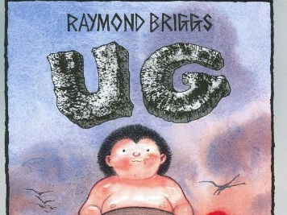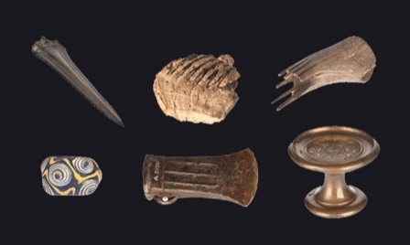

**History – What was life like in prehistoric times?**

Learning to place events from their own lifetime and key events in history on a timeline.

To use evidence to describe the past.

To use evidence to find out how events may have changed during a time period.

Describe similarities and differences people events and objects.

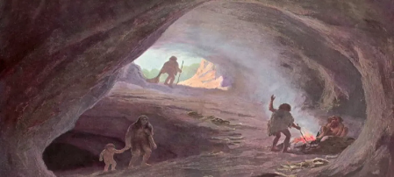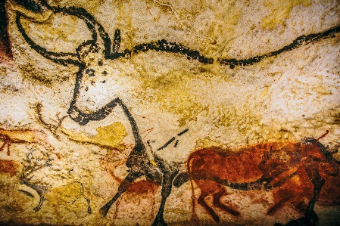

**Science**

**Term 1: Rocks and Soils – How are rocks, soils and fossils are formed?**

To investigate how rocks are formed.

To study at how fossils form over time.

To look at the different nutrients present in soil.

**Term 2: Light – How does light impact on our everyday lives?**

To find out about different light sources.

To know that light is needed to be able to see things.

**PE – Outdoor: How can we use tactics to support our game play?**

**Indoor: How can we develop our strength and coordination?**

Term 1 Outdoor: Tag rugby

Term 1 Indoor: Swing Dance

Term 2 Outdoor: Netball

Term 2 Indoor: Football skills.

**RE - What do different people believe about God?**

To talk about ways in which we exercise trust and faith in our everyday lives.

**French – How can we greet people and count in French?**

Saying ‘hello’ and ‘goodbye’, asking ‘how are you?’ and saying your name.

Learning French numbers to ten and music instruments.

Learning about words to describe things in the classroom.

**Computing – How can I program a robot to complete a task?**

To be able to design, write and debug simple algorithms that accomplish specific goals.

**How can I identify the most effective program to publish my work?**

To use a wide range of programs to create documents and presentations.