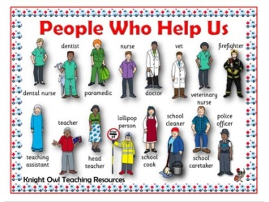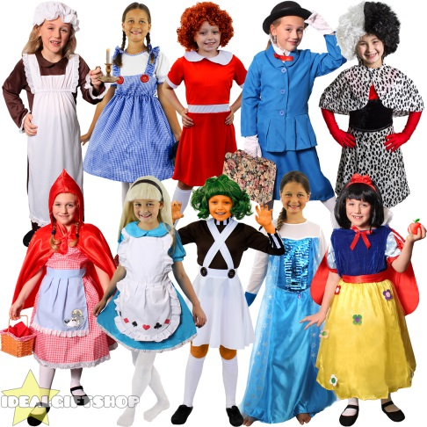

**Term 4**

Welcome back everyone; we hope you had a lovely week off.

This term is a very exciting one as we will be learning all about **‘People Who Help Us’.** Throughout this topic we will be teaching the children lots about different job roles and our community. Each week we will be focussing on a different profession. We will be looking at the emergency services, medical professions, transport and educators.

**World Book Day**

This term on Thursday 5th March it is World Book Day.

On this day we will be celebrating your child’s favourite book and have a range of activities linked to books for your child to take part in.

The children will also take part in an exciting parade.

**EYFS Newsletter**

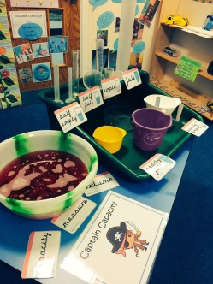

Maths

This term we will be focussing on Shape, Space and Measure. The children will be learning to recognise 2D and 3D shapes. They will also explore capacity, weight, length and height.

Phonics

In Phonics this term the children will be focussing on the digraphs in Phase 3 and practising how to read and write simple sentences.

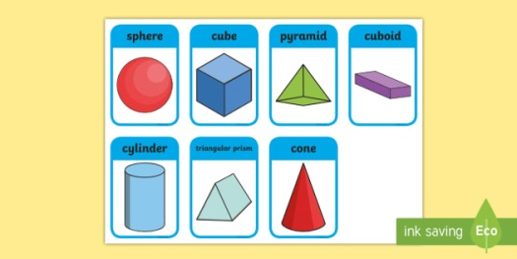

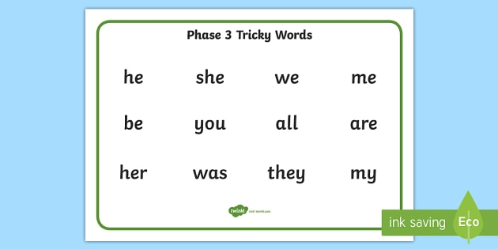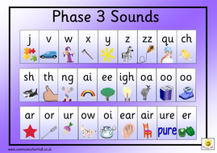



**Well Done!**

We have been very impressed with how hard the children have been working with their home challenges and WOW moments and we recognise the time you take to help your children with these so thank you and we are all very proud of the children’s achievements.

**Key dates to remember…**

* 5th March World Book Day
* 13th March School Book Fair
* 23rd to 24th March Class Photos
* 30th and 31st March Parent Consultations
* 1st April Inset Day

**Reminders…**

* Pleasure check that your child is wearing the **correct school uniform**, the school uniform policy is on our website. The children need to be wearing shirts not polo shirts.
* Please check **your date for ‘Show and Tell’**, lots of children are still brining in show and tell on various days of the week. WOW moments continue to come in as completed.
* Well done to all the children who are reading every day, please **do not forget to write in** **the reading record** so your child can get their well deserved certificate. This also enables us to change your books.
* We are doing indoor PE this term, **please make sure your child’s PE kit is returned** to school so they can take part.